Tab 1

<https://openart.ai/share/Wk1FMm14RmdaTnVoVU8wdUFhcGE7aHR0cHM6Ly9jZG4ub3BlbmFydC5haS91cGxvYWRzL2ltYWdlX3VFdkxrdWUzXzE3NDkwNjMxMTYwMDZfNTEyLndlYnA>

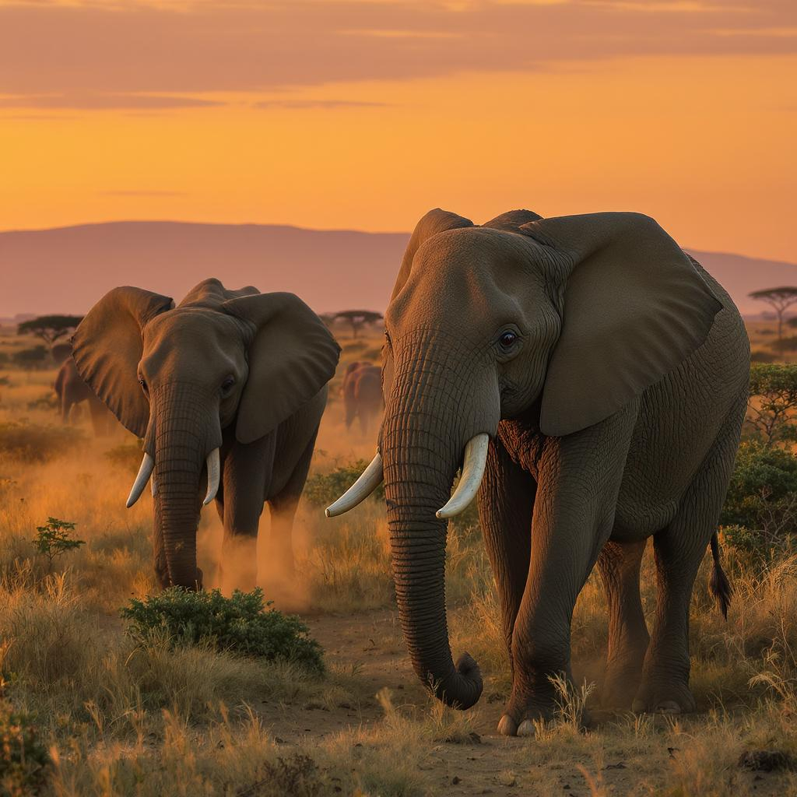+

Tab 2

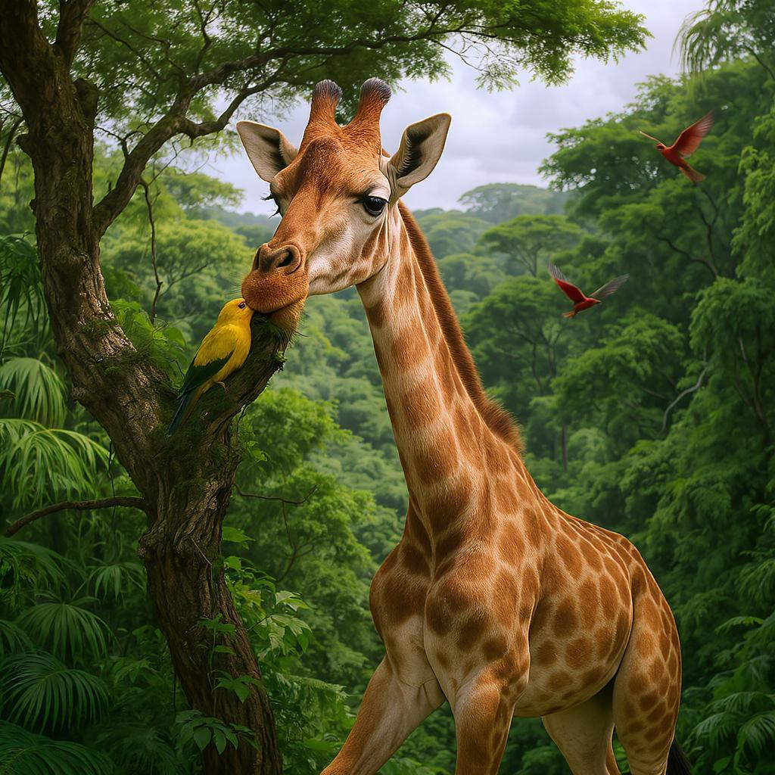

Tab 3

https://openart.ai/share/Rk5JREhLSExYT0dmN3d2elp3aFM7aHR0cHM6Ly9jZG4ub3BlbmFydC5haS91cGxvYWRzL2ltYWdlX3V3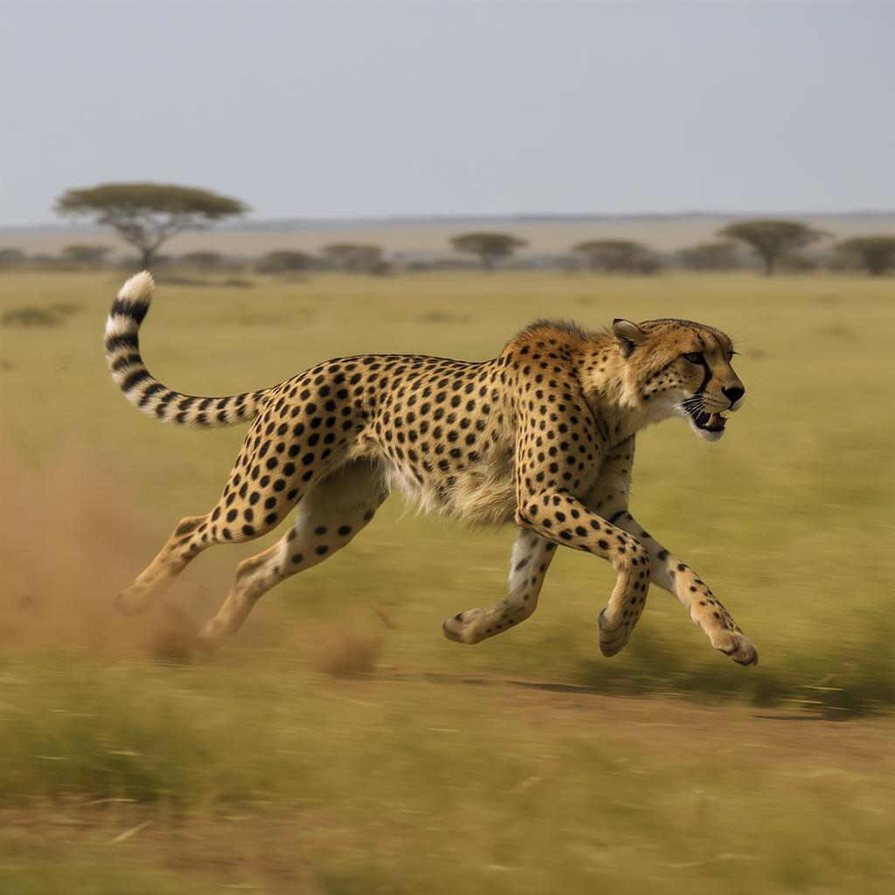SDFTX21WXzE3NDkwNjMzMzEwNTNfNTEyLndlYnA-